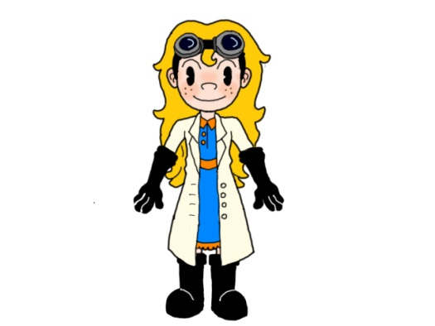**Mrs. Wojtowicz’s 2019-2020**

**2nd Semester Policies**

**Suggested Materials**

* Three Ring Binder
* Pencils
* Pencil Pouch/Case
* Calculator (optional)

**Classroom Rules:**

**The Malow Respect Code must be observed by all students at all times.**

Be respectful to everyone and everything in the room

Be on time and be prepared

No Food (gum is not food!)

No cheating

**Cheating:**

***Mrs. W’s definition of cheating:*** *copying off another student or allowing someone to copy off of you!*

If a student is caught cheating the following consequences will occur:

**1st time:** Student will receive a zero on the assignment and a parent will be notified.

**2nd time:** Student will receive a zero on the assignment, parent will be notified, a N in citizenship, and a referral to the office.

**Cell Phones:**

Students can use their cell phones at school before 8:00 am, during lunch, and after 3:01 pm. Teacher approval is required for all cell phone use in the classroom. Students are expected to place their phone in the cell phone caddy near the door as they enter the classroom. If students do not place their phone in the caddy the teacher may confiscate the phone until the end of the day and issue a 30-minute detention as a consequence.

**Tardies:**

When three tardies are accumulated, a 15-minute detention will be issued. Detentions after the third tardy will increase by 15 minutes per tardy. If tardiness becomes excessive citizenship may be affected.

**Inappropriate Behavior:**

1. Verbal warning

2. Removal from classroom/written assignment and parent contact

3. Detention

4. Office referral

***\*In the event of severe classroom disruption students will be sent immediately to administrators in the office.***

MC900280811[1]

**Make-up/Absent Work:**

1 day to make up assignments will be provided for each day missed. **Students are responsible** for finding out what they missed while they were absent. Students may check wojscience.weebby.com or ask another student from their class and hour. Students must then pick up the assignment(s) from the absent work folders below the calendar by the door in the classroom. A student must talk to the teacher about any concepts he/she does not understand. Once all absent work is completed it should be turned in to the absent work tray on top of the drawers for each hour by the door.

**Teacher Website**:

Each morning I will post the daily agenda on my website as well as important dates such as upcoming tests. To access my science site, go to wojscience.weebly.com. All handouts and homework assignments can be downloaded and printed from this site in the event a student is absent from school or has misplaced an assignment.

**PowerSchool:**

Please take advantage of PowerSchool, it is a wonderful resource that has been designed so that you are always informed of your progress in class. Grades will be updated in PowerSchool on a regular basis. If you feel that there is a mistake with your grade, please see Mrs. Wojtowicz with the assignment in question so that changes can be made if necessary.

**Grading Scale:**

A 100-94% B 87-83% C 77-73% D 67-63%

A- 93-90% B- 82-80% C- 72-70% D- 62-60%

B+ 89-88% C+ 79-78% D+ 69-68% F 59% or lower





***Grading: Your grades (categories of assignments) will be weighted in class and are not based on total points earned.***

**Homework (All homework is averaged together and count as 20% of the total grade)**

It is the students’ responsibility to be sure that all homework is complete, with a name, AND turned in on time.

*Homework (and studying) is considered practice. The more you practice something, the better you will become at it. If you never practice, what do you think will happen?*

**Laboratory Experiments (All labs are averaged together and count as 30% of the total grade)**

The class will be conducting lab experiments throughout the semester. The students will either work with a partner or in groups to conduct the experiment but will always do lab reports/conclusions individually. *Working together on lab conclusions and/or questions is considered cheating and students will be disciplined as previously described.*

*Scientific investigations (labs) are an opportunity to help us answer questions and prove/disprove the knowledge you have been “practicing” from class. Conducting experiments will allow you to see and better understand how the concepts we are learning about apply to the real world, as well as explore the question…”why do I need to know this?” or “when will I EVER use this?”*

**Quizzes/Tests (Tests and quizzes will be averaged together and count as 50% of the total grade)**

Quizzes will be given on a regular basis (yes, sometimes they will be unannounced!) to monitor student progress. Tests will be given at the conclusion of each unit. Notification will be given at least one week in advance for all tests.

*Tests should be thought of as the big game! If a football player decided to skip most of the team practices and didn’t learn many plays, do you think he would lead his team to a win? Do you think his coach would even risk putting him in the game? Would he even want to be in the game?*

Almost everyone gets nervous for tests, it is just natural. The amount of days (not just hours) spent “practicing” can reduce your anxiety level tremendously! Try to make it a habit to “practice” daily so you are prepared for the game!

**Extra Help:**

Extra help is available most days before or after school. If you would like to come in for extra help, please notify me in advance so I can plan accordingly. If you are having trouble in science, it is important that you ask for help right away- do not wait until the day before a test to get help!

*If you have any questions or concerns please feel free to contact me by email or phone.

I am looking forward to a great semester!

MC900287501[1]

Nicole Wojtowicz

[nicole.wojtowicz@uticak12.org](mailto:nicole.wojtowicz@uticak12.org)

586.797.3559